Kafka with WebConsole.

<https://github.com/yahoo/kafka-manager>

<https://github.com/claudemamo/kafka-web-console>

when kafka webconsole comes up, it will be shown like this.

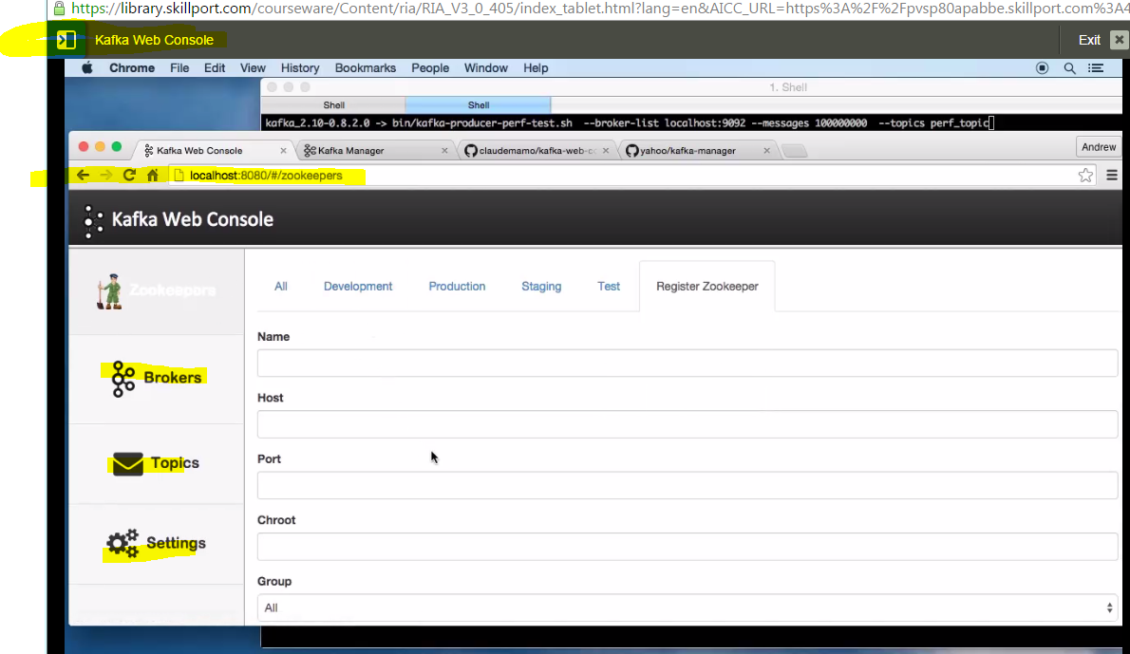

Create new zookeeper inside kakfa webconsole to track zoo keeper messages.

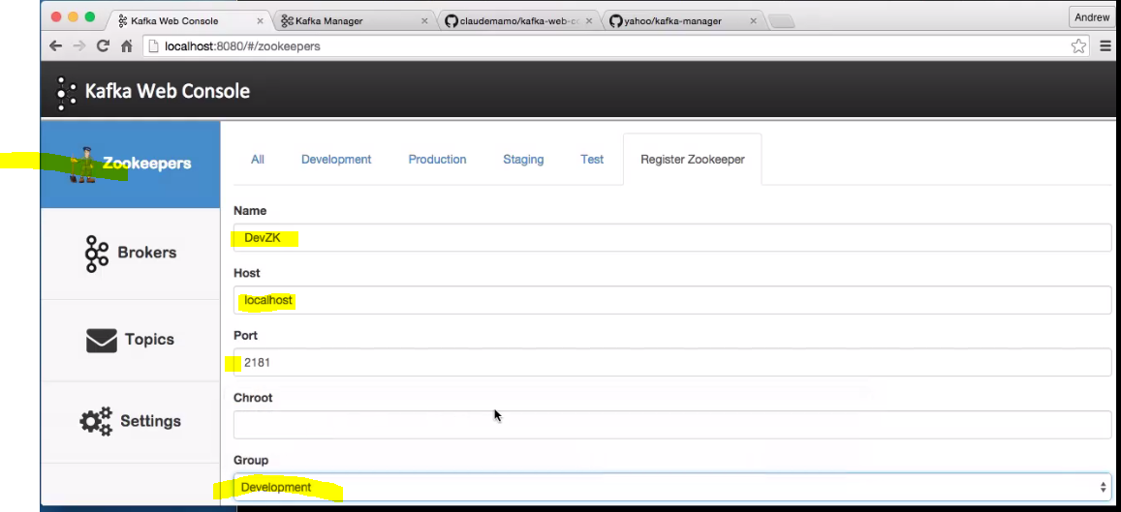

Change to prod, dev and stage when needed by creating new ones.

If up and running, it gets connected.

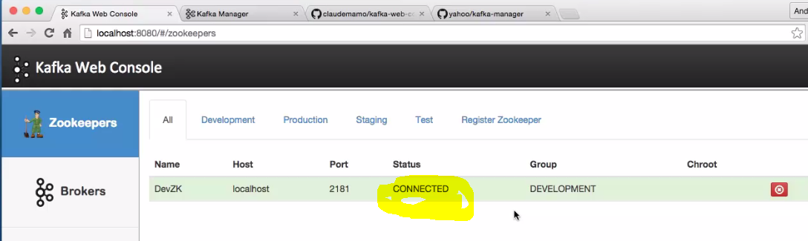

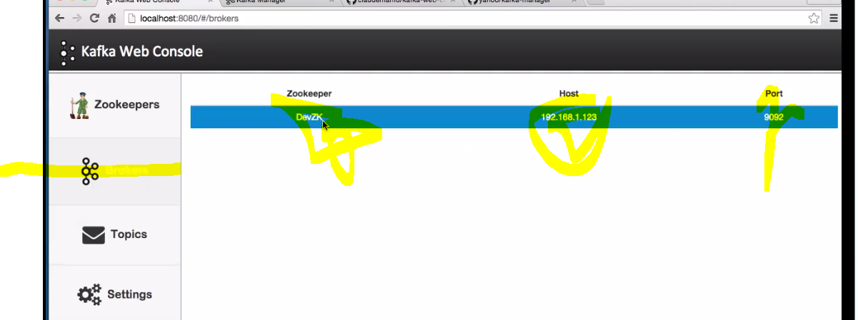

Shows brokers and topics automatically after configuring kafka web console.

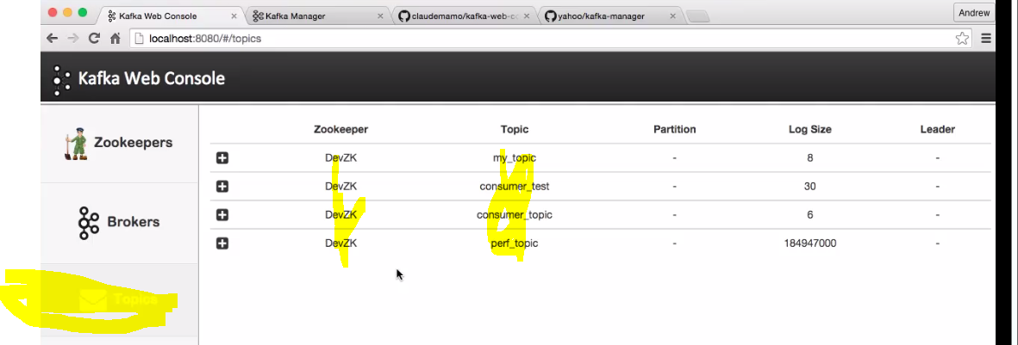

Topics are created automatically.

**2. Kafka Manager 🡪 Console**

<https://github.com/yahoo/kafka-manager>

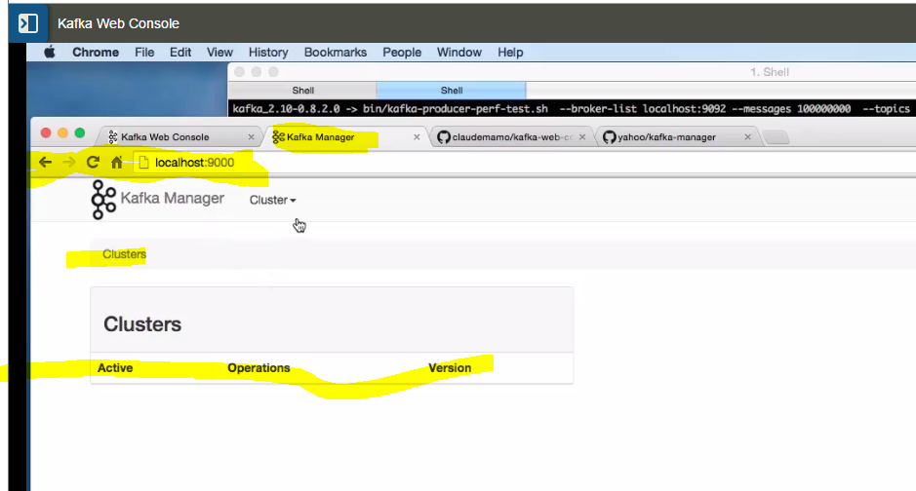

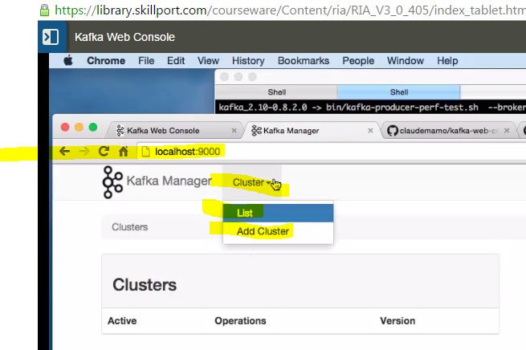

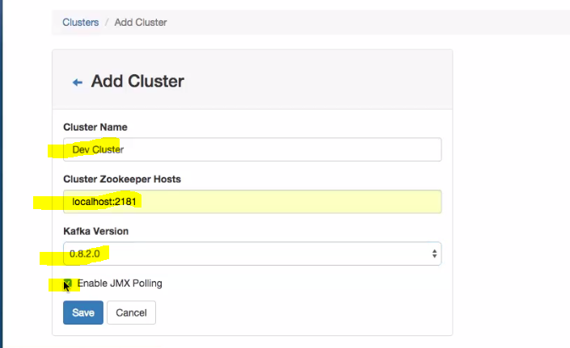

**Use dev_cluster as name if you see any errors.**

**Click on go to cluster view.**

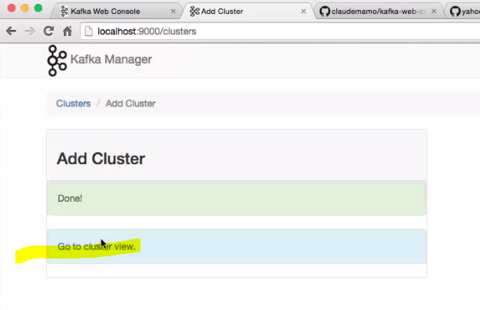

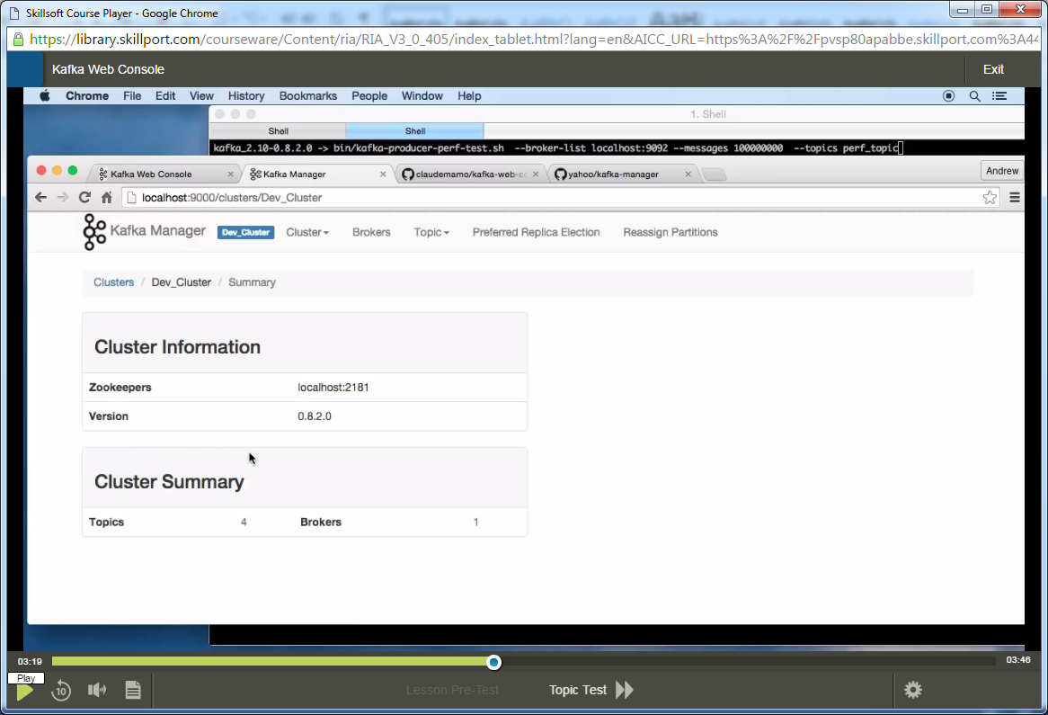

**Click on brokders tab on top.**

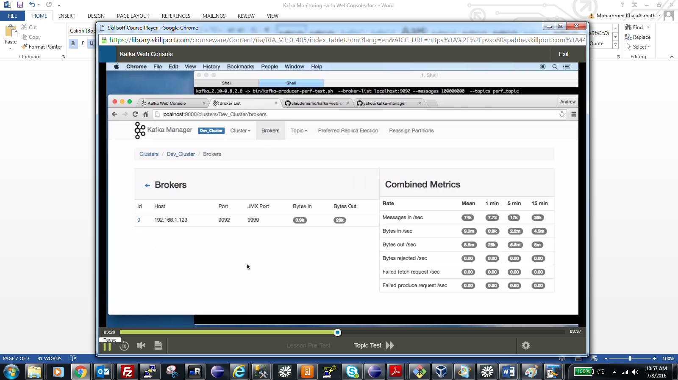

**See right side, bytes in bytes out messages.**

**Number of topics etc ect**

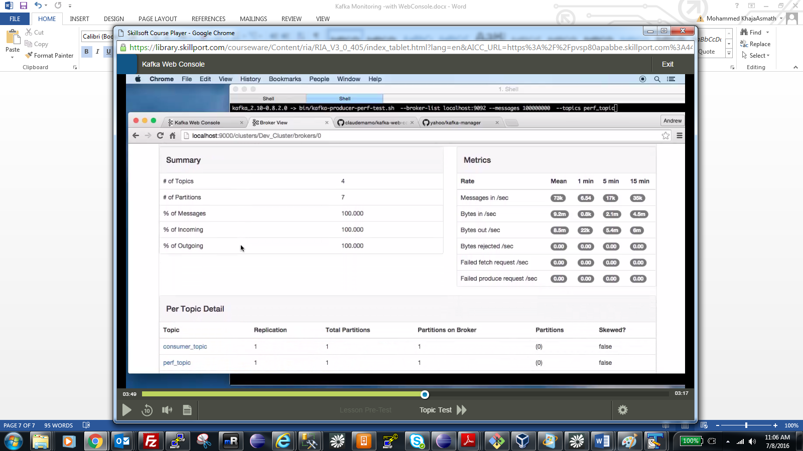

**Click on particular topic**

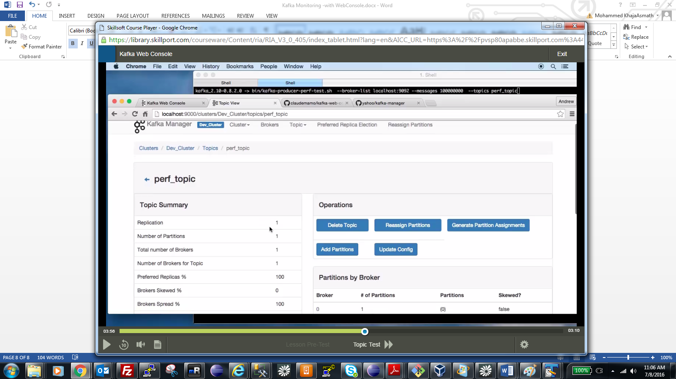

**Once you create topics , you can see messages coming inside kafka.**

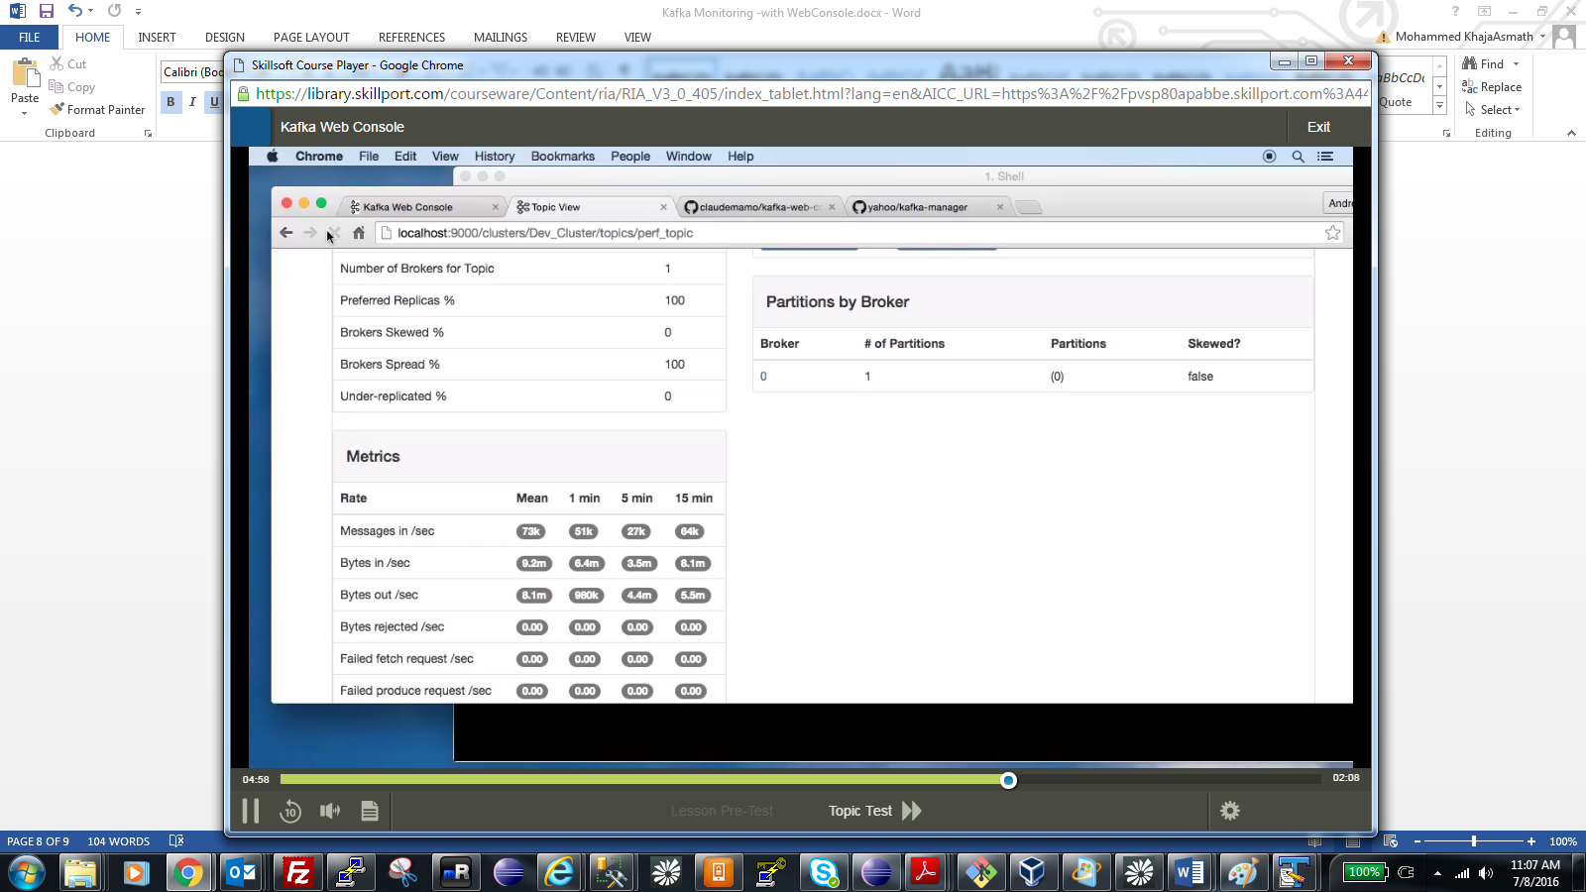

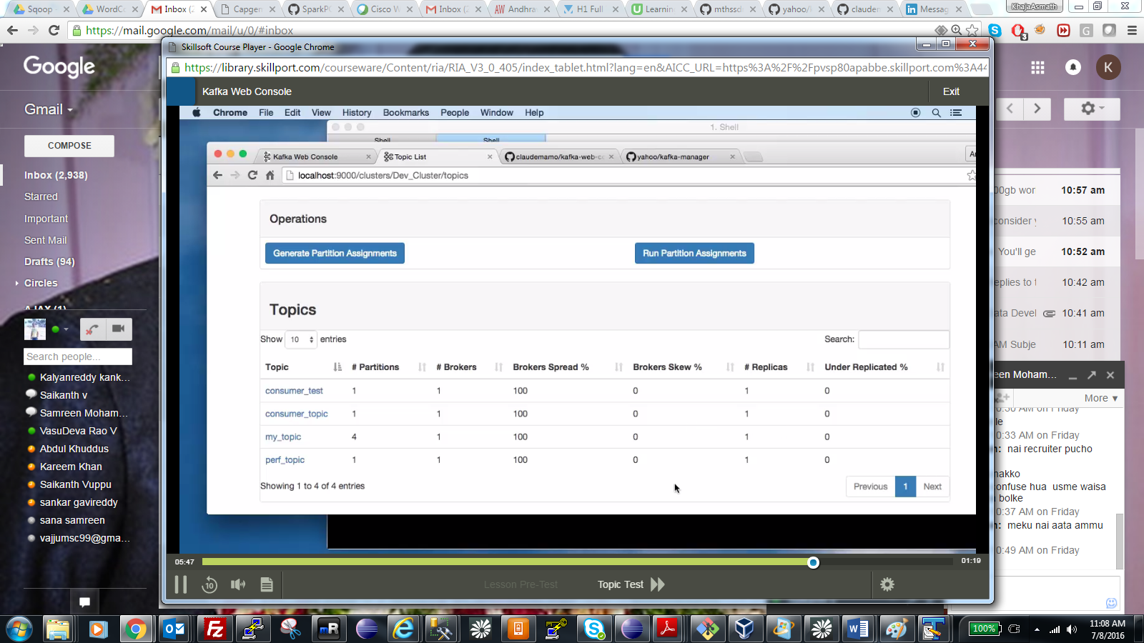

**Create Topic in kafka web console.**

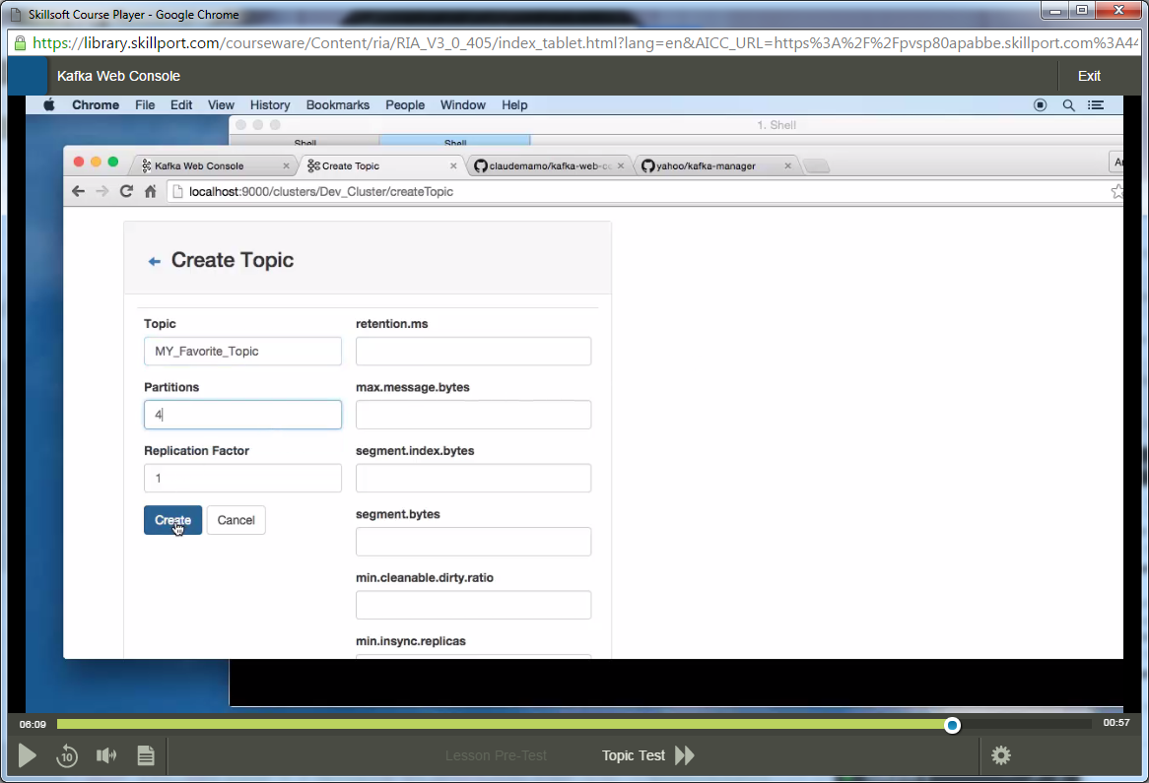

**After creating, click on go to topic view.**

